

Software Project Planning  
Gym Management System

(GMS)

COMP 246 - SEC.061

Group 6: Teleisha Hall || Baljeet Kalsi || Douglas Krein || Amandeep Singh || Sal Velaga

|  |  |
| --- | --- |
|  |  |

MONTH DAY YEAR

|  |
| --- |
|  |
|  |

Table of Contents

Domain 4

Summary 4

Gantt Chart 5

Work Flows 6

1. General flow 6

2. Insert/Update gym information 8

3. Register customer 10

4. Check gym capacity 12

5. Check gym reports 14

6. Check classes and schedules 16

USE CASES 18

Use Case Lists 18

Use Case Diagrams 20

Use Case Descriptions 22

Extended Use case Descriptions 22

UC-101 - Register Customer 22

UC-102 - Update Class Schedule 24

UC-103 - Check Gym Capacity 26

UC-104 - Update Gym Capacity 28

Short Use Case Descriptions 30

UC-105 - Signup for Class 30

UC-106 - View Class Schedule 30

Domain Class Diagram 31

Technological/Developmental Tools 32

System Sequence Diagrams 33

CRC Cards 35

Design Class Diagram 36

Mock-up UI’s 37

ERD Model 39

Design Sequence Diagram 40

State Diagrams 41

Component Diagram 42

Deployment Diagram 42

Stub-Code 42

References 47

**GYM MANAGEMENT SYSTEM**

**Domain**

Gym Management System (GMS) is an application (APP) used by people who work out at gyms and sometimes find them packed; causing them to waste time in the gym without machines to work out. GMS includes user and gym registration, view classes and schedules, view/update gym capacity and generate reports to manage and optimize time for exercising.

# Summary

In the first day at gym, the customer requests registration. The manager inputs the information into the system and if everything is correct, the manager issues an access card to the customer, who then creates a new password to access the application. The customer has to swipe his/her card to enter in the gym and at this moment, the system will count the number of persons in the gym and display the information live in the application. If the customer wants, it is possible to check information anytime such as, gym capacity, reports about previous gym usage traffic and also classes and schedules.

# GMS Gantt Chart

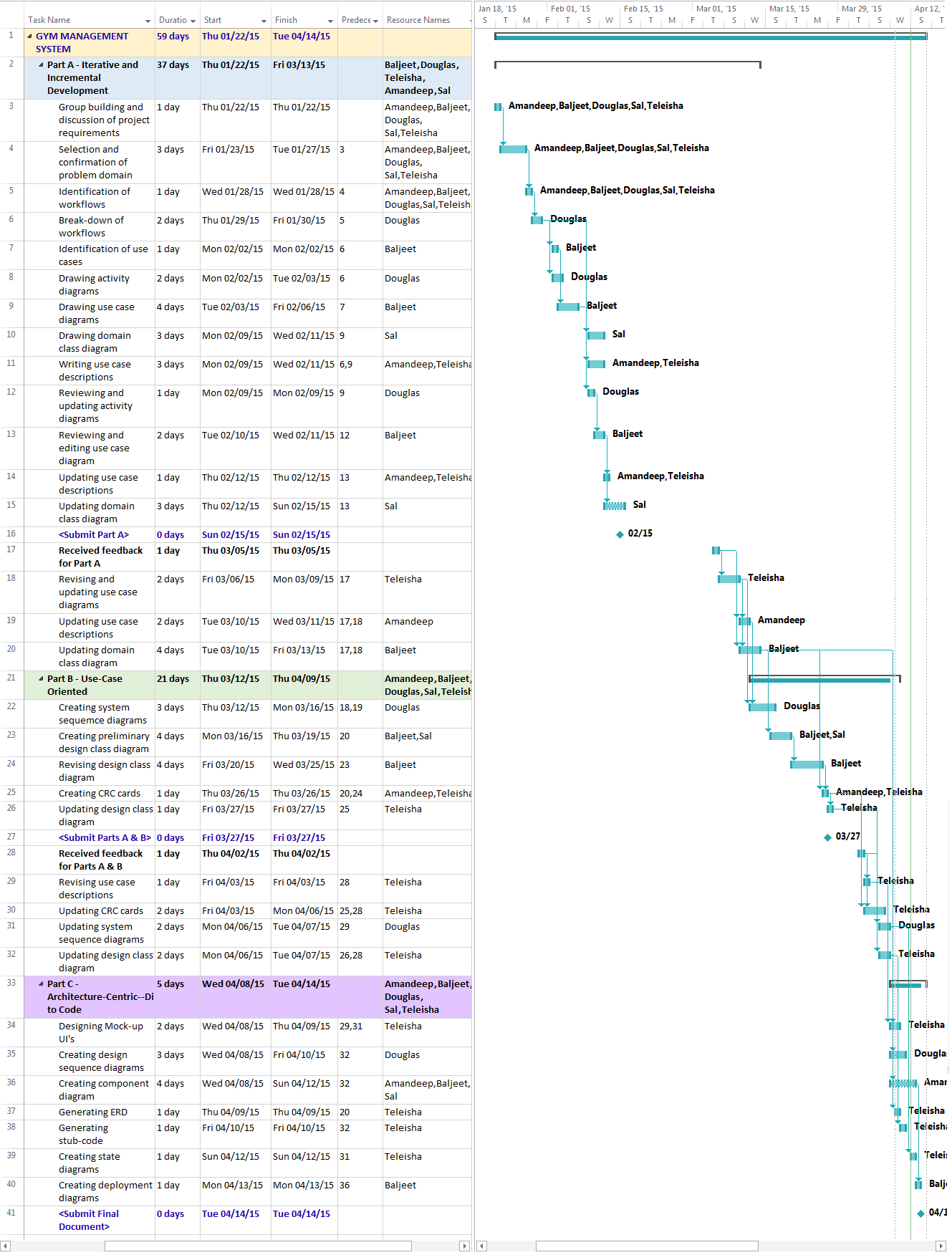

# Work Flows

## General flow

* 1. Customer request registration
  2. Manager requires customer information
  3. Customer provides personal information
  4. Manager enter the information in the system
  5. System validates the information
  6. System finish registration
  7. Manager issues an access card for customer
  8. Customer swipe the access card
  9. System requires a password
  10. Customer informs password
  11. System validates password
  12. System give access to the system
  13. Now with access card and password user access the system to consult
  14. Customer select for which gym he wants the information
  15. System display selected gym’s information
  16. Customer select which option wants to check: Capacity, Reports or Classes and Schedules
  17. System show the selected option
  18. Customer analyze the information and decide if worth go to gym

***General flow Activity Diagram***

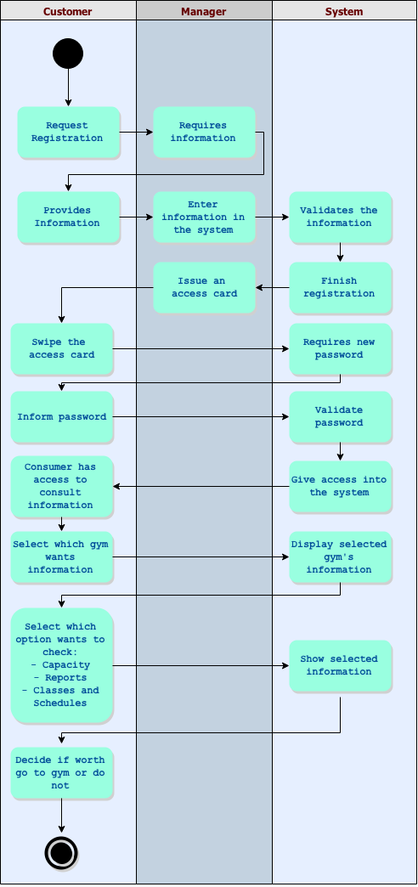

## Insert/Update gym information

* 1. Manager with admin access will login in the system
  2. System verifies login information
     1. If the login is invalid, the system will show a message asking the correct information
     2. If the login is valid, the system will enter in a screen with some information about the gym
  3. Manager updates all information, for example address, pictures, capacity, photos, classes and schedules
  4. Manager saves new information
  5. System validates the information
     1. If the information is not ok, system inform problems and ask manager for the information again
     2. If the information is ok, the system saves the information and all users can see the new information

***Insert/Update gym information Activity Diagram***

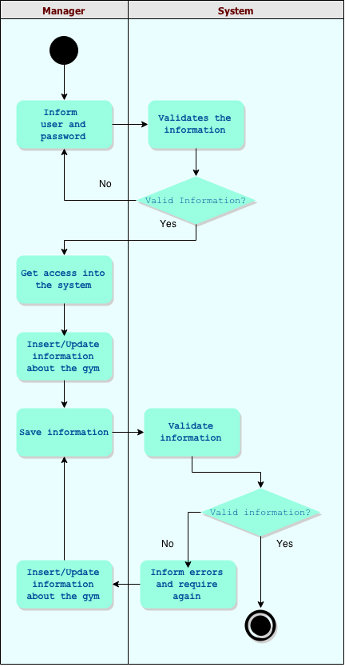

## Register customer

* 1. Customer requests registration
  2. Manager requires customer information
  3. Customer provides personal information
  4. Manager enter the information in the system
  5. System validates the information
     1. If the information is not ok, the manager inform problems and ask the personal information to the customer again
     2. If the information is ok, the manager issue an access card for customer
  6. Customer swipe his access card
  7. System requires a password for the customer
  8. Customer informs the password that will be used to access the system
     1. If the password is not ok, the system informs password problem and requires a new one
     2. If the password is ok, the system finish the registration

***Register Customer Activity Diagram***

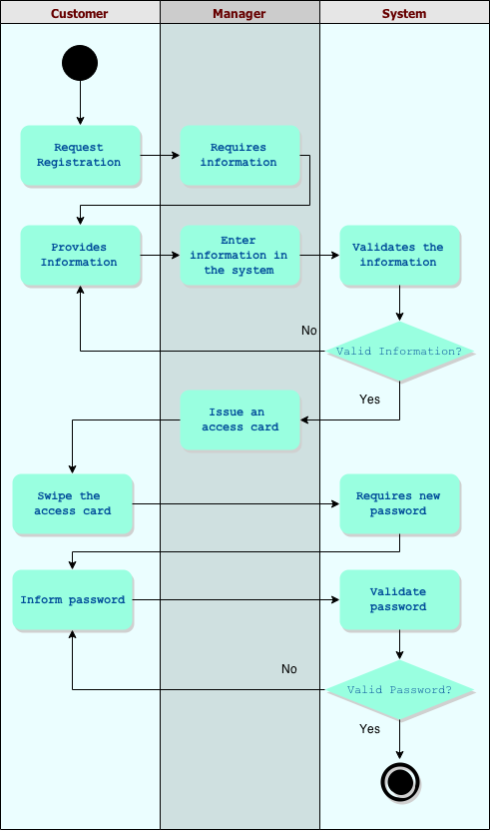

## Check gym capacity

* 1. Customer informs the system from access card and password
  2. System verifies information
     1. If the information is not ok, system requires user and password again
     2. If the information is ok, system give access to enter in the application
  3. Customer select which gym he wants the information
  4. System shown the main page of the selected gym
  5. Customer select the option “Check Capacity”
  6. System verifies how many people swiped them access card into the selected gym and display the information to customer
  7. Customer verifies the information and decides if go to the gym or do not.

***Check gym capacity Activity Diagram***

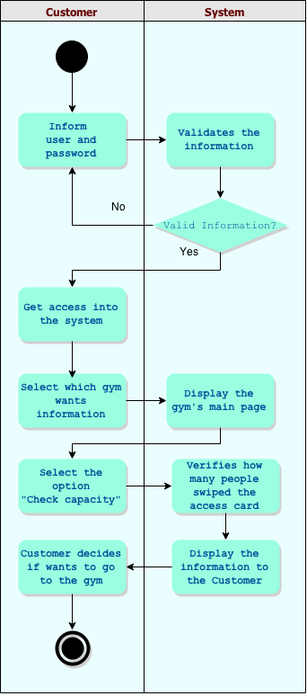

## Check gym reports

* 1. Customer informs his user from access card and password
  2. System verifies information
     1. If the information is not ok, system requires user and password again
     2. If the information is ok, system give access to enter in the application
  3. Customer select which gym he wants the information
  4. System shown the main page of the selected gym
  5. Customer select the option “Check Reports”
  6. System requires which date customer want to see about
  7. Customer informs the date and confirm
  8. System verifies all information about the date and display it to the customer
  9. Customer analyzes the information and see how many people were in the gym at the specified date

***Check gym reports Activity Diagram***

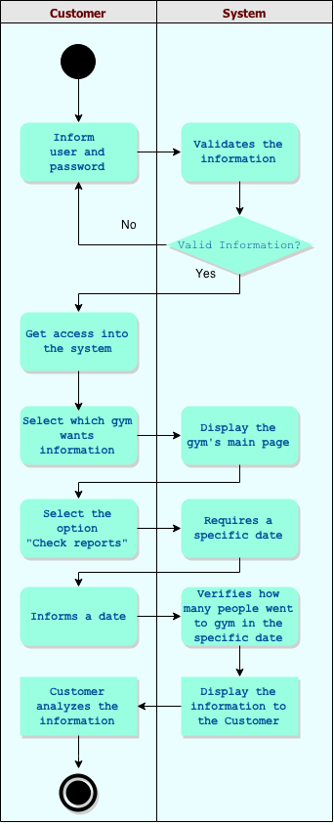

## Check classes and schedules

* 1. Customer informs system through access card and password
  2. System verifies information
     1. If the information is not ok, system requires user and password again
     2. If the information is ok, system give access to enter in the application
  3. Customer select for which gym he wants the information
  4. System shows the main page of the selected gym
  5. Customer select the option “Check Classes and Schedules”
  6. System displays a calendar with the current day selected
  7. Customer chose the day which will be displayed
  8. System display to customer all classes and schedules for that day, in the specific gym selected previously
  9. Customer verifies the information and see if there is any classes in that day

***Check classes and schedules Activity Diagram***

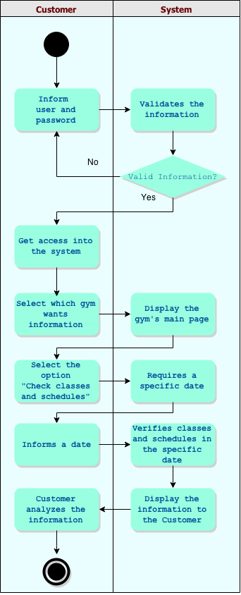

# USE CASES

## Use Case Lists

|  |  |  |  |  |  |
| --- | --- | --- | --- | --- | --- |
| **No.** | **Actor** | **Goal Use Case** | **<Include>** | **<Extend>** | **Priority** |
| 1.1 | -Manager | Register Customer | -Login |  | H |
| 1.2 | -Customer  -Manager | View Gym Information |  |  | M |
| 1.3 | -Customer  -Manager | Update customer information | -Login  -Return Customer Information |  | L |
| 1.4 | Customer  -Manager | Check Gym Capacity | -Login  -Return number of machines  -Return number of members in gym |  | H |
| 1.5 | Customer  -Manager | View Class Schedule | -Login  -Get class schedule |  | M |
| 1.6 | Customer  -Manager | View Class Information | -Login |  | M |
| 1.7 | Customer  -Manager | Check Class Times | -Login  -Get class time |  | M |
| 1.8 | -Customer | Signup for Class | -Login  -Get class schedule  -Get class time |  | M |

|  |  |  |  |  |  |
| --- | --- | --- | --- | --- | --- |
| 2.1 | -Manager | Update Gym Capacity | -Login  -Get current gym capacity |  | H |
| 2.2 | -Manager | Update Class Schedule | -Login  -Get class schedule |  | M |
| 2.2 | -Manager | Update Class Time | -Login  -Get class time |  | M |

## Use Case Diagrams

## Customer Registration:

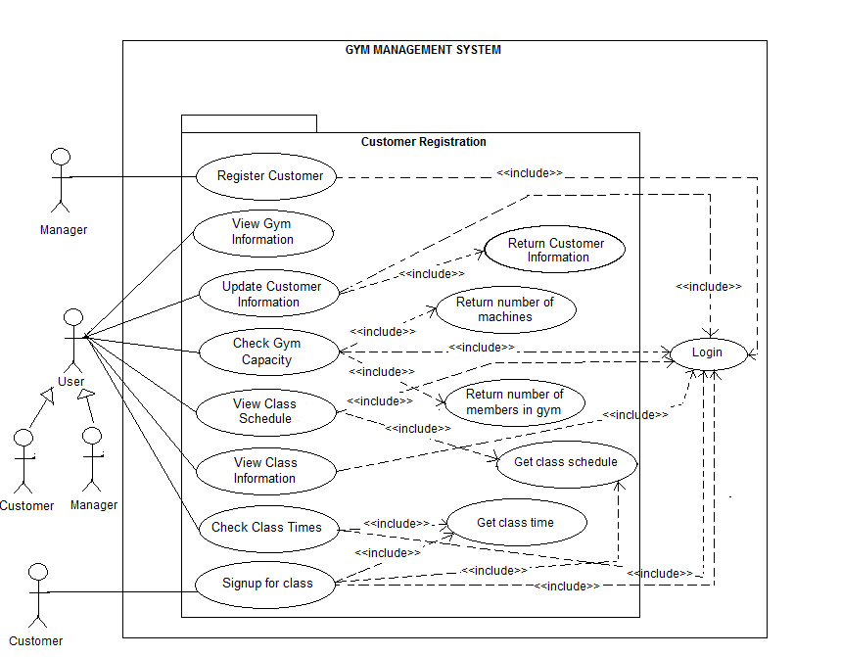

## Gym Maintenance:

## 

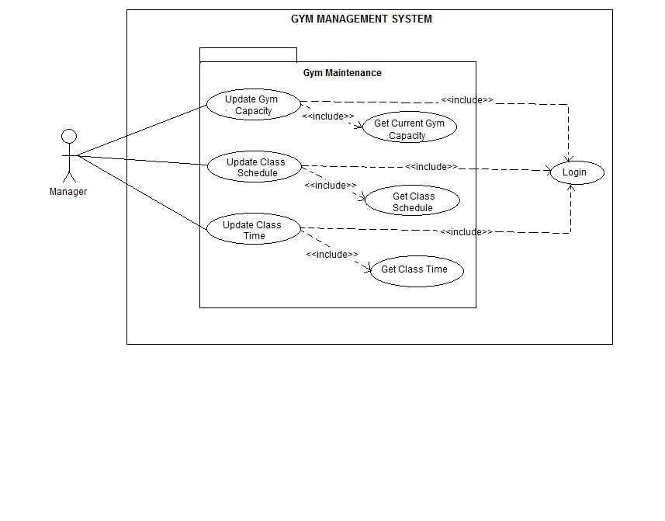

## Use Case Descriptions

**EXTENDED USE CASE DESCRIPTIONS**

|  |  |
| --- | --- |
| **Use Case:** | Register Customer |
| **Use Case ID:** | UC-101 |
| **Super use case:** | None |
| **Scenario :** | Register a new customer in the gym |
| **Triggering Event :** | A new customer requests the registration. |
| **Actor :** | Manager |
| **Description:** | Manager starts application and registers customer |
| **Related Use Cases :** | None |
| **Preconditions :** | -Manager must be logged into the system.  Customer must provide the personal information for the registration. |
| **Post conditions :** | Customer’s information is saved in the system |
| **Flow of Events :** | 1. System asks manager to select a gym branch from displayed list. 2. Manager selects any gym branch. 3. System displays main screen with “Register Customer” and other options available to the manager. 4. Manager selects “Register Customer” option. 5. System displays registration form with “register” button and “clear form” button. 6. Manger collects customer information from customer, inputs it into the registration form and clicks the “register” button. 7. System saves customer information in the system as a new customer and prompts user to swipe access card. 8. Manager issues customer swipe card and swipes card in swipe card machine, which sends card information to system. 9. System generates a username for the customer and sends message to swipe card machine to display password screen. 10. Manager allows customer to enter and confirm new password and selects “ok” button on swipe card machine which sends information to system. 11. System displays alert message “password created successfully” and displays the generated customer username to the manager who then informs customer of his/her username. |
| **Exceptions:** | 1. System verifies login information.    1. If the information is incorrect/ invalid, system displays error message and requests username and password again.    2. If the wrong username and password combination is inputted 3 times in a 5 minutes period, the system places a 30 minutes lock on the user account.    3. After 30 minutes, the user can re-enter his username and password combination,    4. If the user makes 3 more unsuccessful login attempts in the 10 minutes period, the system locks user account again,    5. If the user enters the correct username and password combination, the system grants the user access to the application. 2. System validates customer information.    1. If the information is not valid, the manager informs customer about problems and ask for personal information again.    2. If the information is valid, the system displays success message to the manager and the manager issues an access card to the customer. |
| **Priority:** | High |
| **Source :** | Activity diagrams |

|  |  |
| --- | --- |
| **Use case:** | Update class schedule |
| **Use case ID:** | UC-102 |
| **Super use case:** | None |
| **Scenario:** | Updating class schedule |
| **Triggering event:** | A new class is offered by the gym or a class is dropped by the gym. |
| **Actor:** | Manager |
| **Description:** | Manger changes class schedule for a particular gym branch. |
| **Related Use Cases :** | <<Get Class Schedule>> |
| **Pre-conditions:** | Manager must be logged into the system. |
| **Post-conditions:** | The class schedule is updated. |
| **Flow of Events:** | 1. System asks manager to select a gym branch. 2. Manager selects a gym branch from a list displayed by the system. 3. System displays main screen of selected gym branch with “Update Class Schedule” and other options available to the manager. 4. Manager selects “Update Class Schedule” option. . 5. System gets the existing class schedule for the selected branch and displays it to the manager with “add class” and “delete class” options. 6. Manager can select a class and click the “delete class” button and the selected class would be removed from the list. 7. Manager can also select “add class” button. The system would display pop-up screen with 2 input text fields and a “save” button, one field requiring the name of new class and the other requiring the class days. The manager clicks save and the system adds the inputted class to the class schedule list. 8. System displays class schedule with changes made by the manager. |
| **Exceptions:** | System verifies login information   1. If the information is incorrect/ invalid, system displays error message and requests username and password again. 2. If the wrong username and password combination is inputted 3 times in a 5 minutes period, the system places a 30 minutes lock on the user account. 3. After 30 minutes, the user can re-enter his username and password combination, 4. If the user makes 3 more unsuccessful login attempts in the 10 minutes period, the system locks user account again, 5. If the user enters the correct username and password combination, the system grants the user access to the application. |
| **Priority:** | Medium |
| **Source:** | Activity diagram |

|  |  |
| --- | --- |
| **Use Case :** | Check gym capacity |
| **Use Case ID:** | UC-103 |
| **Super Use Case:** | None |
| **Scenario :** | Checking the capacity of the gym. |
| **Triggering Event :** | Customer wants to check if gym is full or not |
| **Actors :** | Customer |
| **Description :** | Customer selects a gym branch and checks the capacity of the gym and number of members present to decide if the gym is full or not. |
| **Related Use Cases :** | Update Gym Capacity |
| **Preconditions :** | -Customer must be registered with gym company.  -Customer must be logged into the system. |
| **Post conditions :** | Customer can view the current capacity of the gym |
| **Flow of Events :** | 1. System asks the customer to select a gym branch. 2. Customer selects a gym branch from a list displayed by the system. 3. System displays main screen of selected gym branch with “Check Gym Capacity” and other options available to the customer. 4. Customer selects the option “Check Gym Capacity.” 5. System gets the total number of machines at the selected gym branch and displays it as “gym capacity” to the customer. 6. System verifies how many people swiped their access card into the selected gym branch and displays the information to customer as “members present” at gym. 7. Customer reviews the information and decides if he should go to the gym or do not. |
| **Exceptions:** | System verifies login information.   1. If the information is incorrect/ invalid, system displays error message and requests username and password again. 2. If the wrong username and password combination is inputted 3 times in a 5 minutes period, the system places a 30 minutes lock on the user account. 3. After 30 minutes, the user can re-enter his username and password combination, 4. If the user makes 3 more unsuccessful login attempts in the 10 minutes period, the system locks user account again, 5. If the user enters the correct username and password combination, the system grants the user access to the application. |
| **Priority:** | High |
| **Source :** | Activity diagrams |

|  |  |
| --- | --- |
| **Use case:** | Update gym capacity |
| **Use case ID:** | UC-104 |
| **Super use case:** | None |
| **Scenario:** | Updating the current gym capacity |
| **Triggering event:** | The number of machines in the gym changes |
| **Actor:** | Manager |
| **Description:** | Manager changes the capacity for a particular gym branch. |
| **Related Use Cases :** | <<include>> Get current gym capacity |
| **Pre-conditions:** | Manager must be logged into the system. |
| **Post-conditions:** | The new gym capacity is saved on the system |
| **Flow of Events:** | 1. System asks the manager to select a gym branch. 2. Manager selects a gym branch from a list displayed by the system. 3. System displays main screen of selected gym branch with “Update Gym Capacity” and other options available to manager. 4. Manager selects ‘Update Gym Capacity’ option. 5. System gets the current gym capacity for the selected branch and displays it to the manager along with an input text field and submit button. 6. Manager enters new gym capacity in the input text field and clicks submit button. 7. System replaces current gym capacity with the value entered by manager and issues pop-up message: “capacity updated.” |
| **Exceptions:** | System verifies login information.   1. If the information is incorrect/ invalid, system displays error message and requests username and password again. 2. If the wrong username and password combination is inputted 3 times in a 5 minutes period, the system places a 30 minutes lock on the user account. 3. After 30 minutes, the user can re-enter his username and password combination, 4. If the user makes 3 more unsuccessful login attempts in the 10 minutes period, the system locks user account again, 5. If the user enters the correct username and password combination, the system grants the user access to the application. |
| **Priority:** | High |
| **Source:** | Activity diagram |

**SHORT USE CASE DESCRIPTIONS**

|  |
| --- |
| **Use case:** Signup for class |
| **Use case ID:** UC-105 |
| **Actor:** Customer |
| **Description:** Customer logs into system. System validates user and displays option “signup for class”. Customer selects the option. System displays classes and schedules. Customer selects class. System checks class capacity and number of members registered for the class. If number of members registered is less than class capacity, system increments number of members registered by 1 and displays message “successfully registered” to customer. If numbers of members registered equals class capacity, system displays message “class full” to user. |

|  |
| --- |
| **Use case:** View class schedule |
| **Use case ID:** UC-106 |
| **Actor:** Customer |
| **Description:** Customer informs the system through access card and password and System verifies the information. System gives access to enter in the application. Customer select for which gym he wants the information. System shows the main page of the selected gym, Customer select the option “Check Class Schedule”. System displays a calendar with the current day selected, Customer chose the day which will be displayed. System display to customer all classes and schedules for that day, in that specific gym. |

# DOMAIN CLASS DIAGRAM

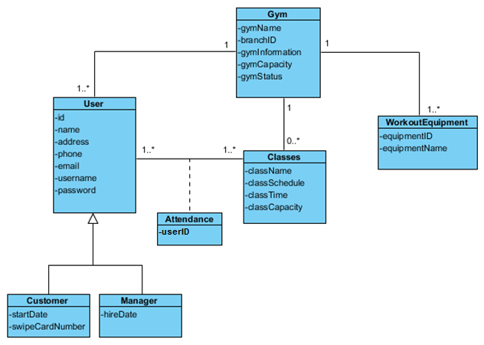

# TECHNOLOGICAL TOOLS FOR SOFTWARE DEVELOPMENT

|  |  |  |  |  |
| --- | --- | --- | --- | --- |
| 3-Tier Architecture | | Development Tools | Comments | |
| Presentation Tier | * HTML/CSS (website) * ASP.NET (registration) * JavaScript (website, form validation) * Java ME (mobile applications) | | | This is the interface where the user will interact with the system. |
| Business Tier | * XML * ASP | | | This is where the system will process commands, perform calculations and evaluate them to make decisions. |
| Data Tier | * SQL Server | | | Customer and gym information will be stored and retrieved from this database system. |

**SYSTEM SEQUENCE DIAGRAMS**

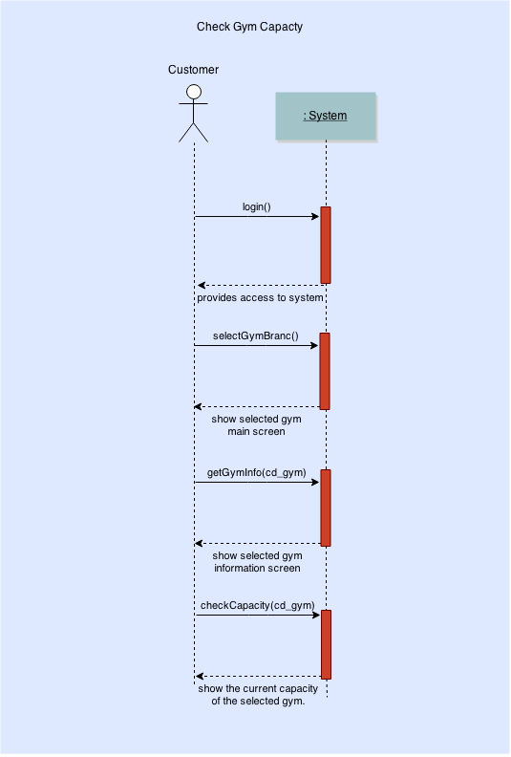

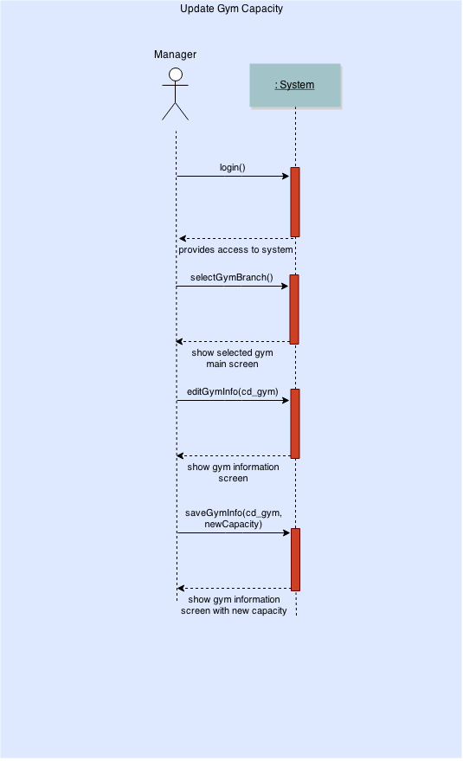

**CRC Cards**

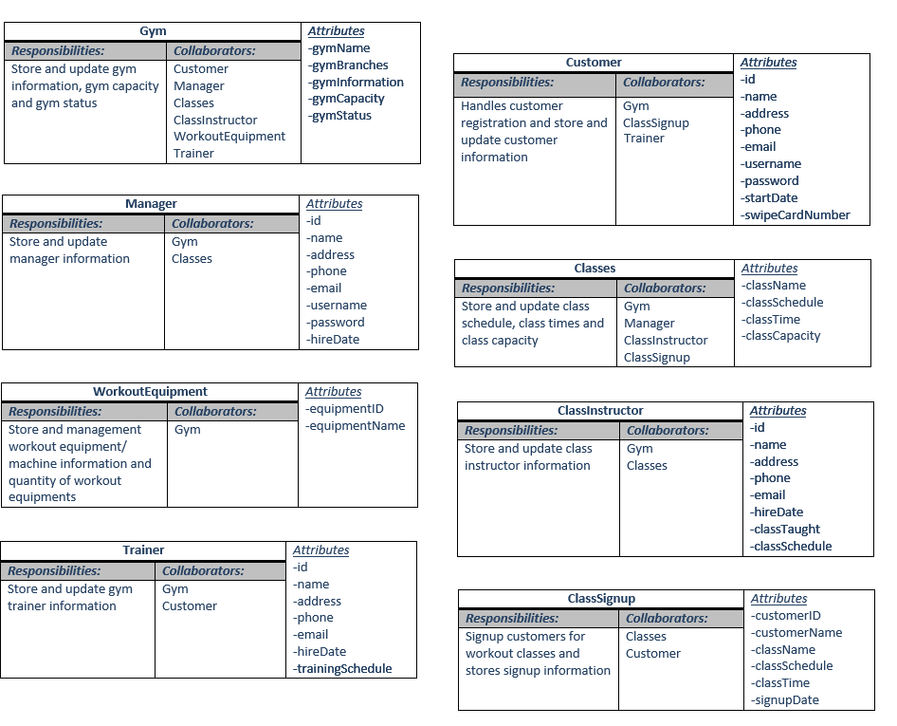

**DESIGN CLASS DIAGRAM**

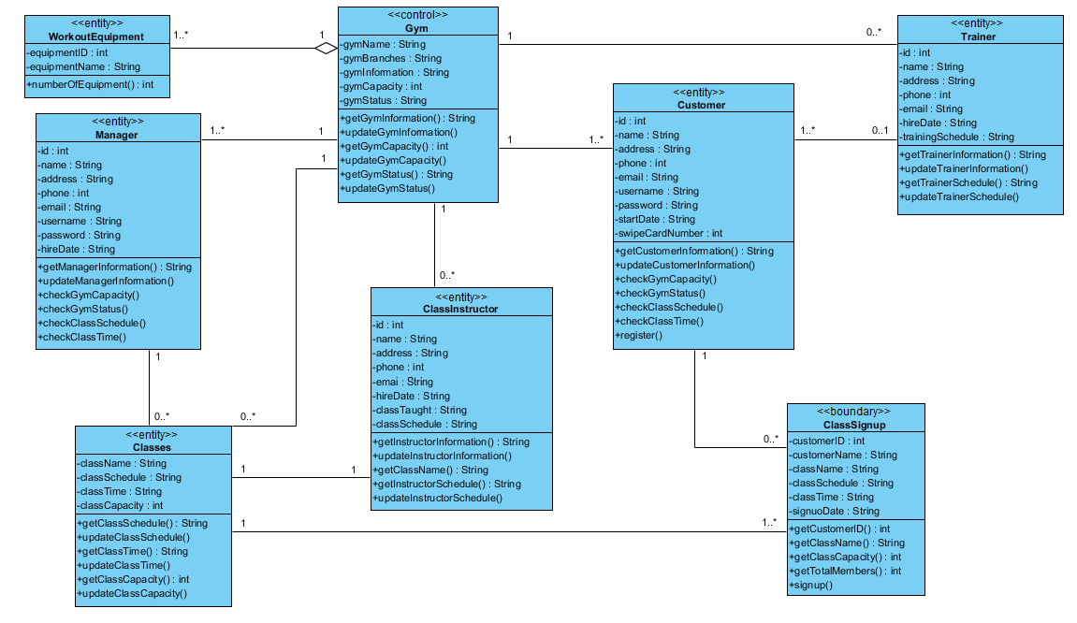

**MOCK-UP USER INTERFACES**

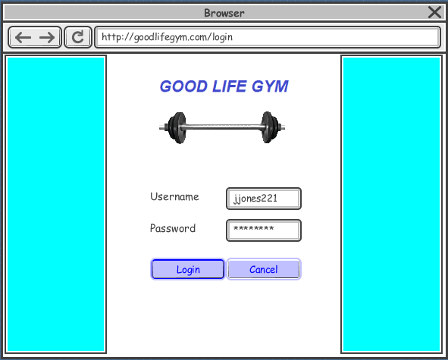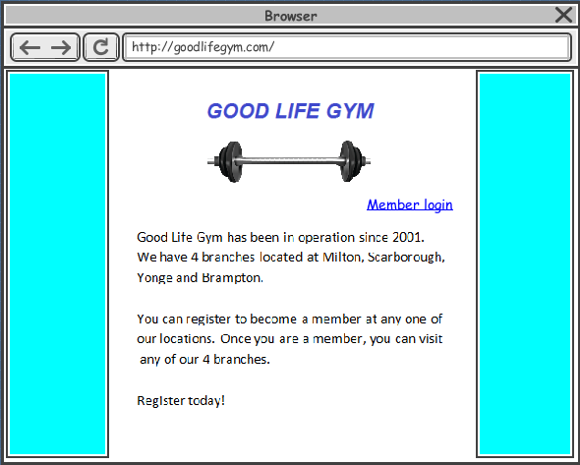**Check Gym Capacity**

**Fig. 1 Fig. 2**

Anyone can type the gym’s website address in a browser and the system will display the gym’s homepage as seen in fig.1. However, to login, a gym member/customer will click the “member login” link and the system will display the customer login screen (fig.2). The member will login to the system with the username received and password created upon registration.

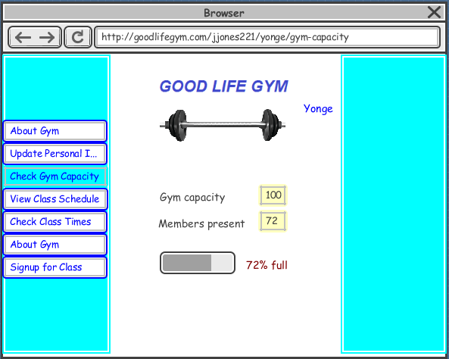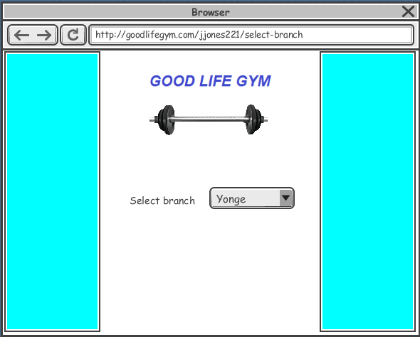

**Fig. 3 Fig. 4**

After the member has logged into the system, the system will ask the member to select a branch (fig.3). After selecting a branch, the user will click the “check gym capacity” tab and the system will display the capacity and status of the gym as shown in fig.4.

**Update Gym Capacity**

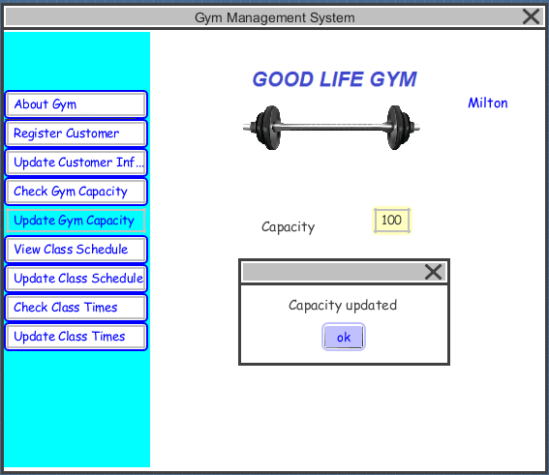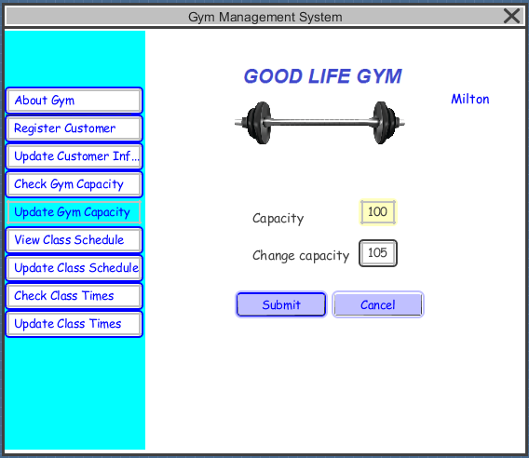

**Fig. 5 Fig. 6**

After the manager has logged into the system, he/she will select the “update gym capacity” tab and input a new capacity value for “change capacity” in fig. 5 and submit. The system will alert message “capacity updated” as shown in fig. 6.The gym capacity value will then be updated to the new value inputted.

**ERD MODEL**

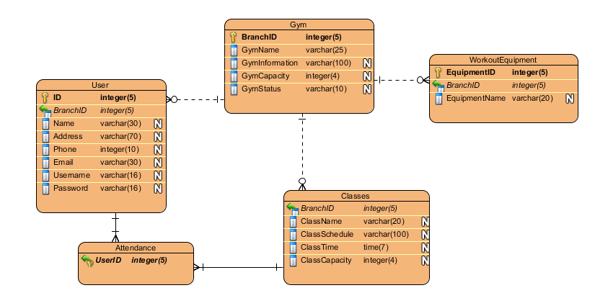

**DESIGN SEQUENCE DIAGRAM**

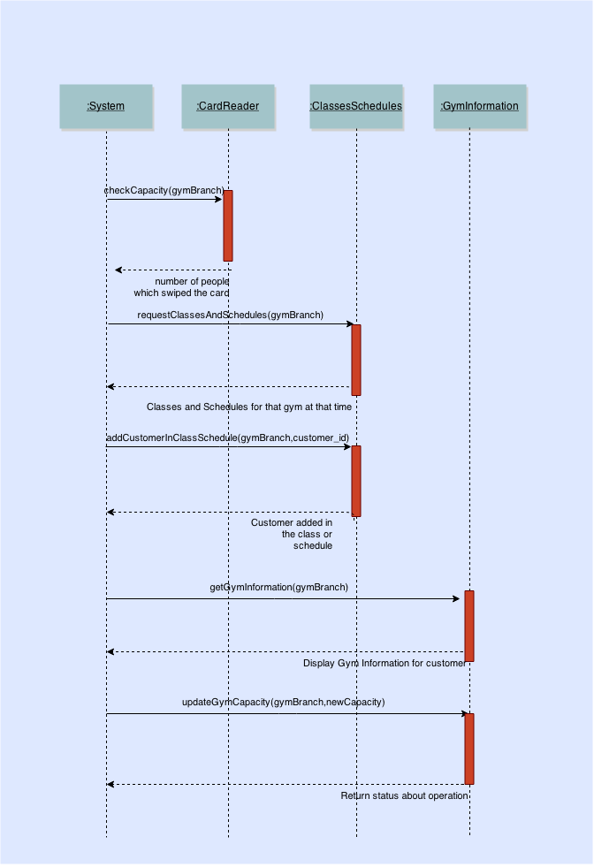

**STATE DIAGRAMS**

**Check Gym Capacity**

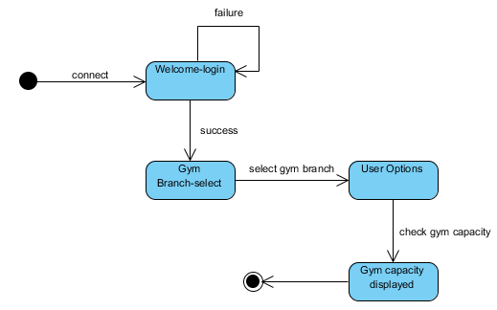

**Update Gym Capacity**

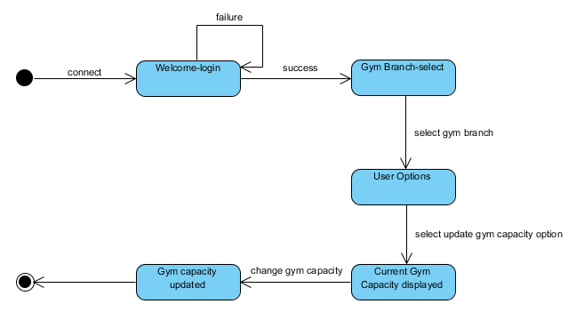

**COMPONENT DIAGRAM**

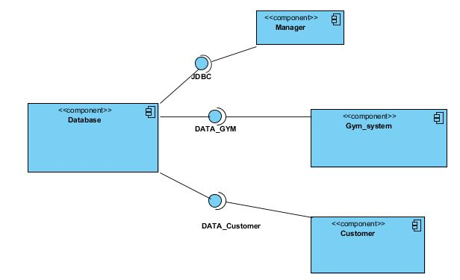

**DEPLOYMENT DIAGRAM**

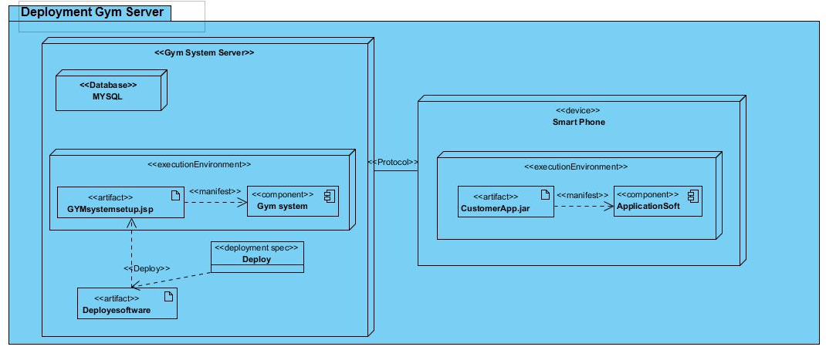

**STUB-CODE**

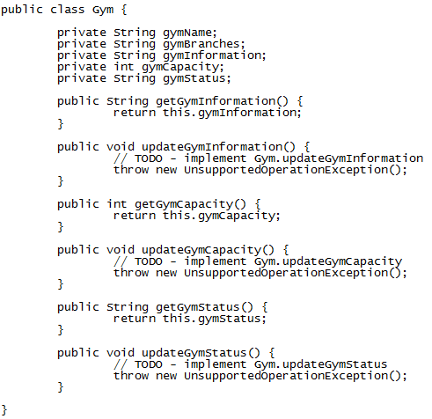

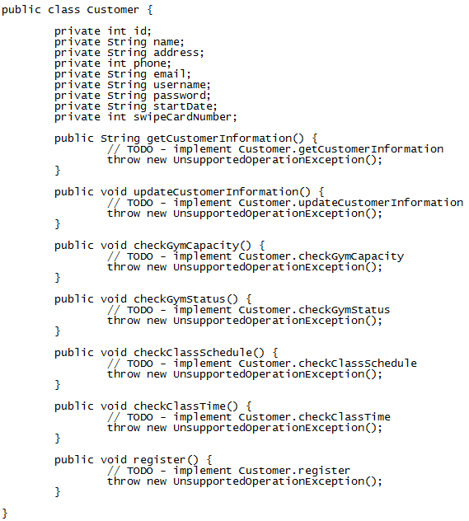

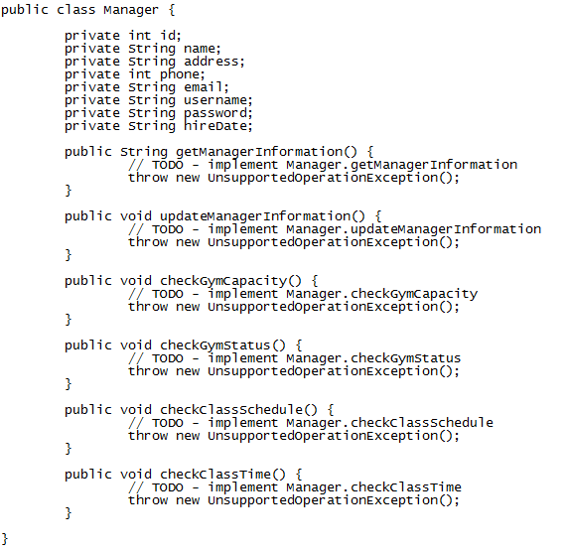

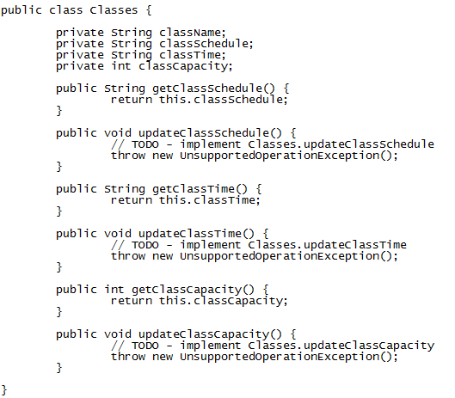

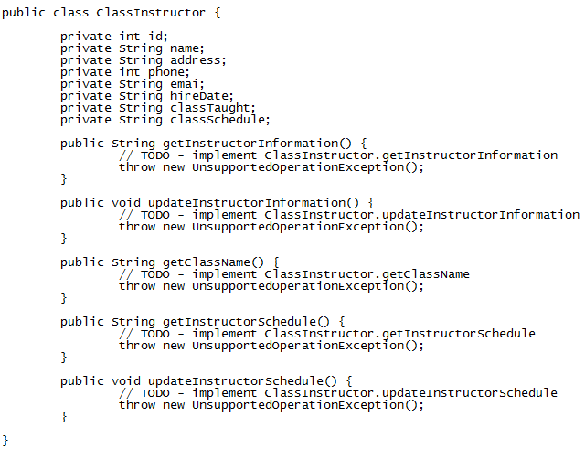

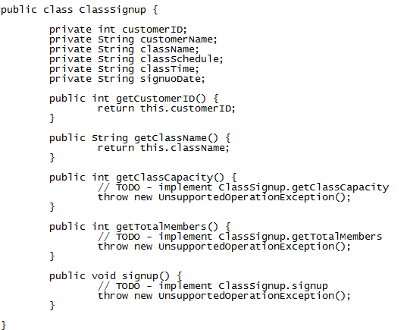

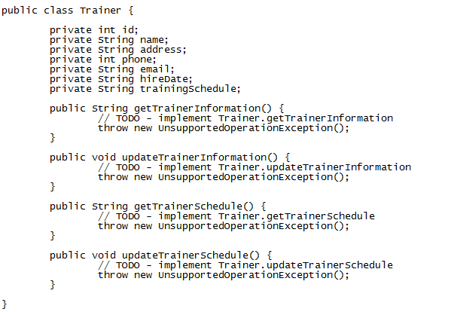

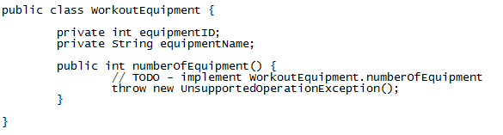

**REFERENCES**

1. Tutorials Point. (n.d.). *UML – State chart diagrams.* Retrieved April 12, 2015, from <http://www.tutorialspoint.com/uml/uml_statechart_diagram.htm>

# 2. Visual Paradigm. (2010, May 10), *Java code generation from class diagram.* Retrieved April 10, 2015, from <https://www.visual-paradigm.com/tutorials/roundtrip.jsp>

# 3, Visual Paradigm. (2011, April), *Generate ERD relationship from UML association in class diagram*. Retrieved April 9, 2015, from <https://www.youtube.com/watch?v=HqKZOgvCeUo>